**Struktur Database Classicmodels**

**Table Customers**

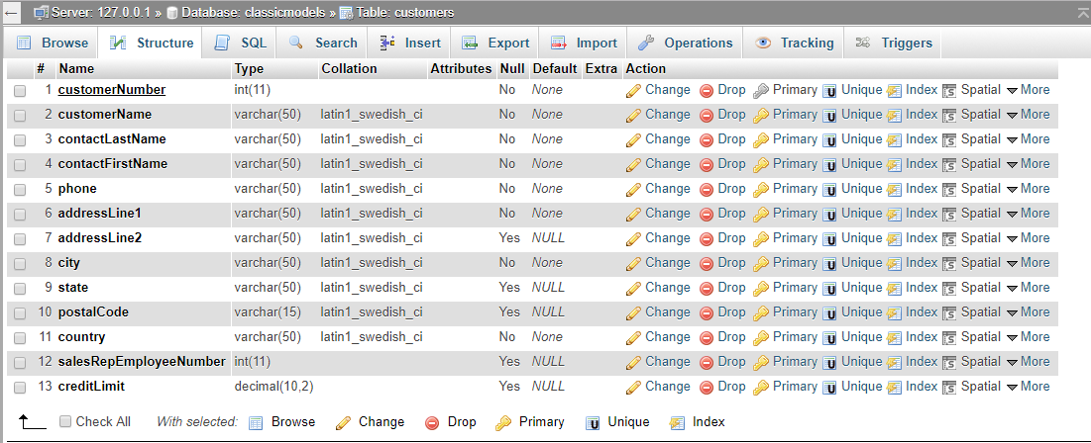

**Table Employees**

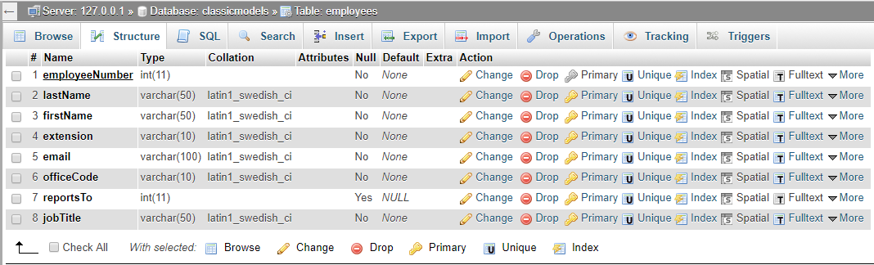

**Table Offices**

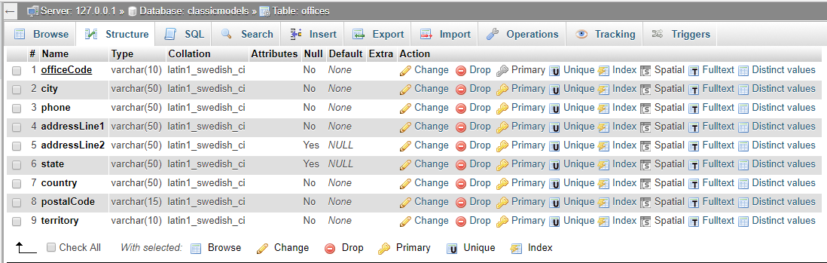

**Table Orderdetails**

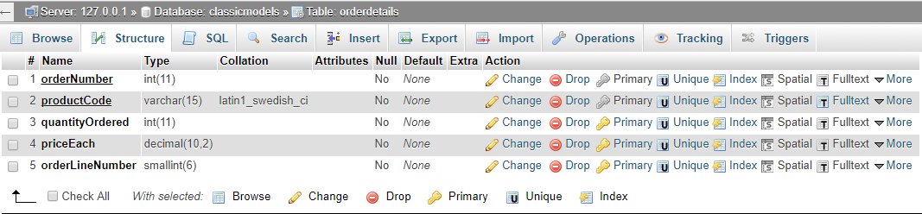

**Table Orders**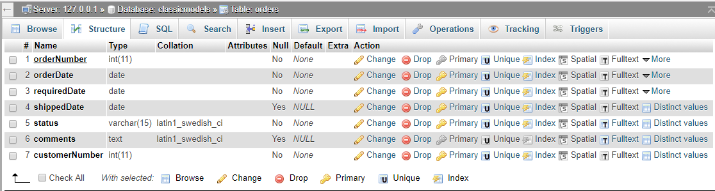

**Table Payments**

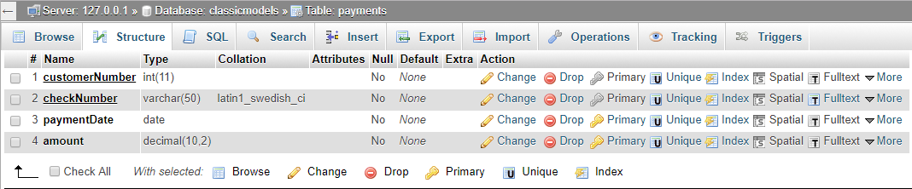

**Table Productlines**

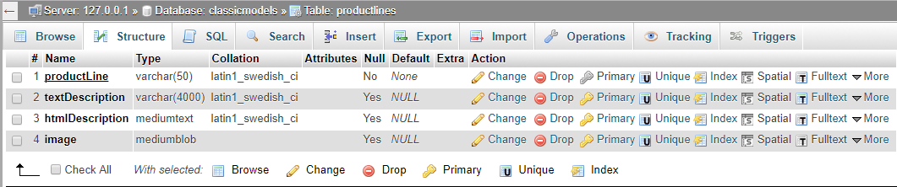

**Table Products**

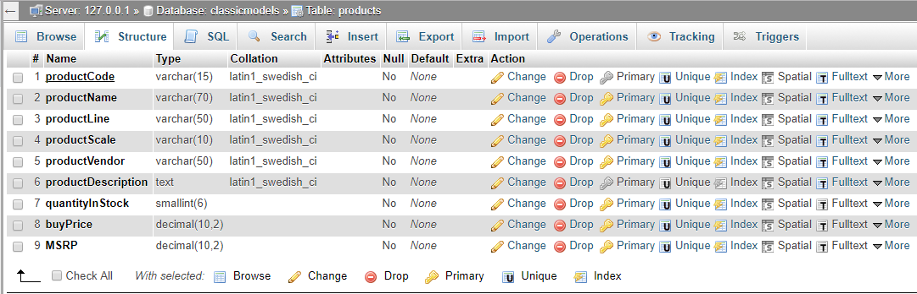

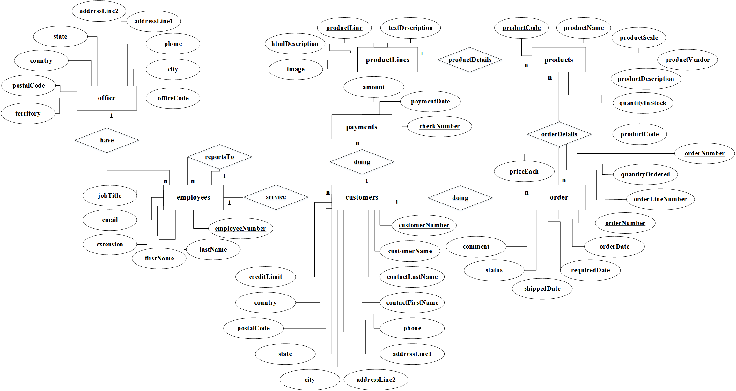Diagram ERD